Dabane 

Siqala ngamanzi

Dabane Trust Dabane Water Workshops

**_____ Reg No. MA 2011/92 ______ ________________________ Reg No. 25/2013 ______________________**

**Environmental Conservation Guide**

***“Our Environment, Our Responsibility”***

**Website :** [**www.dabane.org**](http://www.dabane.org)

**Linked In :** [**https://www.linkedin.com/company/dabane-trust/**](https://www.linkedin.com/company/dabane-trust/)

**Facebook :** [**https://www.facebook.com/DabaneWaterWorkshops/**](https://www.facebook.com/DabaneWaterWorkshops/)

**Youtube :** [**https://www.youtube.com/@dabanewaterworkshops1109**](https://www.youtube.com/@dabanewaterworkshops1109)

**Twitter :** [**https://twitter.com/Dabanewaterwork**](https://twitter.com/Dabanewaterwork)

**Environmental Conservation Guide**

The ideal environmental conservation and land management strategy is based on ‘Soil water storage’. The principle is the infiltration of rainfall directly into the soil where it falls, before there is appreciable movement and erosion of the land surface. On rangeland, the systems comprise infiltration trenches (also known as swales and dead-level contours), half-moons, bunds and gabions. In arable land, the infiltration systems are basins and zaï farming, Listers, tied-ridges and ‘potholes’. Within Zimbabwe, these systems are known as ‘Ntwasa’ (Ndebele) and Pfumvudza (Shona).

In semi-arid areas that typically comprise immature sandy soils, an evapotranspiration rate four times the annual rainfall and an approximate eight-month dry season means the soils have very little organic matter and are easily eroded. To prevent the loss of soil and productive land, rainfall must infiltrate the soil as quickly as possible before it gathers momentum and erosive power. Infiltration systems are best constructed above and on any appreciable slope. Any excavation needs to be wide and shallow so that an animal cannot fall in and hurt itself. Excavated soil is placed below the ‘trench’ to form a bank and is as important as the trench.

Such infiltration and water spreading systems are important. Where rainfall has collected and has formed a rill that will probably become a gully, an infiltration trench, dead-level contour or a bund will prevent water from entering a rivulet and will allow the water to infiltrate into the soil, preventing soil erosion and gully formation and so harvesting rainfall and runoff water for productive use. In addition to the construction of water and soil harvesting systems, the establishment of locally growing tree species, naturally establishing ground cover and appropriate fodder crops should be encouraged as should forest management. The removal of invasive species, thinning of vegetation that is impenetrable to livestock and the brashing of the lower branches of immature trees to allow ground cover, particularly indigenous grasses to establish, are further requirements.

If these systems are utilised above a slope where there is a gully (udonga), a further increase in the area of the gully and a loss of productive land is prevented.  Where a gully is not extensive, rock bunds or gabions constructed across the gully slows the velocity of water sufficient for sediment in transport to be deposited and thus rehabilitate the gully.  This soil generally contains tree, grass and weed seeds that germinate in the entrapped soil to provide ground cover.  Ideally, the throwback of one gabion reaches the base of the immediate upstream gabion so that the velocity of the runoff water is sufficiently slowed to penetrate the trapped soil in the waterway and provide moisture to the germinating seeds.

Infiltration systems above and alongside gulleys that are extensive in depth and width are particularly important.  If erosive runoff water can be prevented from reaching a gully, it will not increase in its extent and little by little there can be rehabilitation of the gully through a natural regrowth process.  Goats will probably be the only grazing and browsing animals that will get into a deep gully and if there is no continuing erosion of the gully their movement will begin to mould the gully into the landscape whilst they deposit tree seeds such as acacia.

Environmental Conservation works are essential methods to prevent gulley formation, improve infiltration of water and recharge underground aquifers. This guide will cover various Environmental Conservation strategies, their establishment and maintenance.

**Site Surveying & Assessment**

**Marking a contour**

It is important that all rainfall, runoff infiltration, and runoff diversion systems are constructed at the same elevation across a slope: on a level contour. If these systems are not on the contour, they are bound to collect water that will not infiltrate into the soil and will continue to flow to a lower level, with the possibility of increasing, rather than preventing, erosion. A dumpy level or theodolite is used to mark a level contour; see figure 1 below. An alternative and significantly cheaper method is to use an ‘A’ Frame, as shown in figures 2 and 3 below.

Making and using an ‘A’ Frame:

**Construction of an A-Frame:**

* **Components**: An A-frame consists of two ‘legs’ connected by a horizontal bar, creating the shape of a capital ‘A’. A plumb line is suspended from the apex.
* **Purpose**: It’s a traditional tool for establishing contour lines on land, dating back to ancient Egypt.

**Assembly Instructions:**

1. **Materials**: Obtain three pieces of timber, poles, or PVC pipes, trimming them to equal lengths (around 2 metres for convenience).
2. **Legs Formation**: Connect two pieces at one end to form an inverted ‘V’.
3. **Cross-Piece**: Affix the third piece equidistantly along each leg from the vertex to create a horizontal cross-piece. If detachable, it enhances portability. (Refer to Figure 2)
4. **Centre Mark**: Ensure the centre of the cross-piece is directly below the vertex and clearly marked.
5. **Plumb Line**: Attach a plumb line at the apex, long enough to swing freely across the centre mark.

**Utilization of the A-Frame:**

* **Levelling**: Place one leg at the start of the contour line, with the other leg pivoting around it to scribe an arc. When the plumb line aligns with the centre mark and both legs touch the ground, the space between is level. Mark this position with pegs. (See Figures 3 and 4)
* **Extending the Line**: Keep the initial leg stationary, rotate the other to form a new arc. Mark the level positions to trace a contour line for trenches, swales, bunds, or half-moons. (Refer to Figure 4)

**Determining Land Slope:**

* **Slope Measurement**: Place one leg of an ‘A’ frame on the ground and lift the other until the plumb line aligns with the centre mark. Measure the distance between the legs (the run) and the height of the raised leg from the ground (the rise). (See Figure 3)
* **Calculating Slope**: Use the measurements to calculate the land’s slope as a percentage or a ratio (1 in x). (Refer to Table 1)

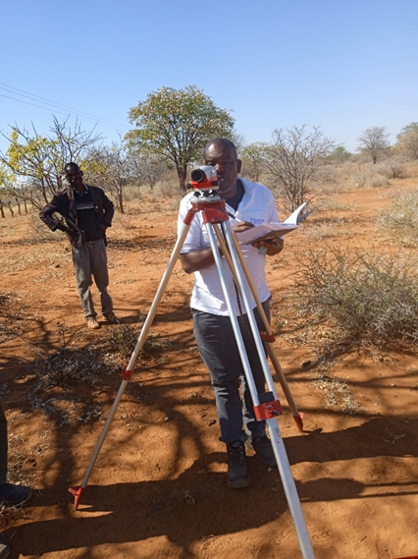 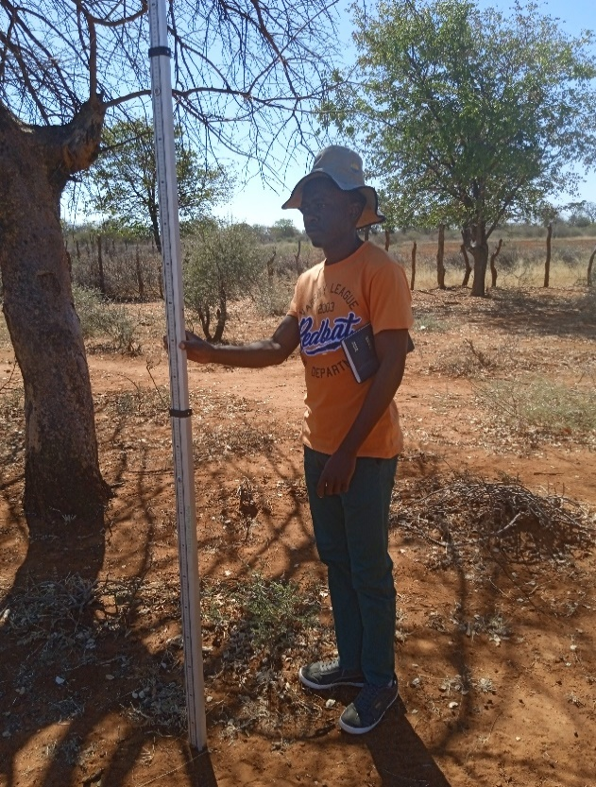

**Figure 1: Using a dumpy level and staff to determine a level contour across a slope (Credit – S. Maseko)**

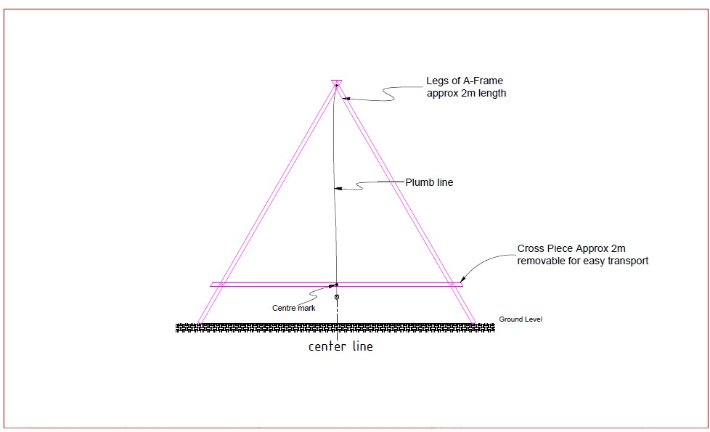

**Figure 2: making an ‘A’ frame to determine a contour (Credit – B. Mpofu)**

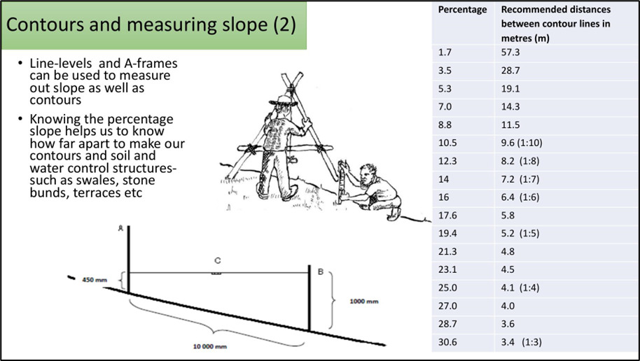

**Figure 3: Using an ‘A’ frame to determine a slope**

****[**https://www.mahlathini.org/our-work/smallholder-decision-support-system/wrc-cca-practices/**](https://www.mahlathini.org/our-work/smallholder-decision-support-system/wrc-cca-practices/)

**Figure 4: Marking a contour line**

[**https://www.mahlathini.org/our-work/smallholder-decision-support-system/wrc-cca-practices/**](https://www.mahlathini.org/our-work/smallholder-decision-support-system/wrc-cca-practices/)

Spacing of Contours

To ensure the most suitable environmental conservation system is used, an estimate of the gradient of the land is required. This can be calculated as a percentage. The horizontal distance (known as the ‘run’) is divided into the loss of height that the run has dropped, (known as the ‘rise’) and is expressed as a percentage. Figure 3 above shows the run, the horizontal distance between points A and B and the rise C. A slope can also be shown as the rise in a given distance, calculated as 1 in x – for example 1 in 33, 1 in 50 etc. See Table 1 below:

Having determined the gradient of the land it is necessary to construct infiltration systems that are of uniform elevation across a slope. That is systems that are on the contour that will prevent the flow of runoff water that transports eroded soil particles down the slope. The optimal distances between two infiltration systems is influenced by the steepness of the land, soil composition and compaction and the rainfall intensity. However, a general guide is that a system lower down a slope should be no more than one metre below the system above. In this way each infiltration system is on a contour at one metre intervals.

General guidelines are:

**Slight slopes**: On gradual slopes with a gradient of less than 5%, infiltration systems can be spaced at intervals of 20 to 30 metres.

**Moderate Slopes**: For slopes with gradients ranging from 5% to 15%, the distance between contours can be reduced to 10 to 20 metres.

**Steep Slopes**: On steep slopes with gradients exceeding 15%, contours should be placed closer together, typically at intervals of 5 to 10 metres.

|  |  |  |  |  |
| --- | --- | --- | --- | --- |
| **% slope** | **rise** | **run** | **1 in** | **Approximate distance between infiltration systems (metres)** |
| 0.5% | 0.50 | 100 | 1:200 | 30 |
| 0.67% | 0.67 | 100 | 1:150 | 25 |
| 0.8% | 0.80 | 100 | 1:125 | 20 |
| 1.0% | 1.00 | 100 | 1:100 | 20 |
| 1.1% | 1.11 | 100 | 1:90 | 17 |
| 1.25% | 1.25 | 100 | 1:80 | 17 |
| 1.43% | 1.43 | 100 | 1:70 | 15 |
| 1.67% | 1.67 | 100 | 1:60 | 15 |
| 2.0% | 2.00 | 100 | 1:50 | 15 |
| 2.5% | 2.50 | 100 | 1:40 | 12 |
| 3.33% | 3.33 | 100 | 1:30 | 12 |
| 5.0% | 5.00 | 100 | 1:20 | 30 |
| 10.0% | 10.00 | 100 | 1:10 | 15 |
| 15.0% | 15.00 | 100 | 1:7 | 7 |
| 20.0% | 20.00 | 100 | 1:5 | 7 |
| 25.0% | 25.00 | 100 | 1:4 | 5 |

**Table 1: Approximate horizontal distance between infiltration systems**

The foregoing are general guidelines to consider when determining the distance apart that infiltration trenches, bunds and water harvesting systems can be constructed. However, to finalise the intervals that the contours can be marked for an infiltration system, it is important to evaluate the site-specific conditions such as the extent of existing soil erosion, the type of soil and its potential to erosion and vegetation cover. The intervals may be moved closer or farther apart using soil texture tests and inspections, making sure the selected system stays on the contour. The primary objective of an infiltration system constructed on the contours is to ensure rainfall is absorbed by the land before there is sufficient water flow to cause erosion and loss of soil and water.

**Methods of rainfall harvesting and infiltration systems**

**I. Infiltration Trenches (Swales, Dead-level Contours)**

Description:

Infiltration trenches are a storm water management technique designed to capture sediment and infiltrate runoff water into the soil. They consist of excavated trenches allowing the water to slowly infiltrate into the land. Infiltration trenches help reduce stormwater runoff and prevent erosion. As water infiltrates into the soil it replenishes groundwater reserves. This increase in available water supports agricultural productivity and will help to ensure a staple food supply.

Dimensions of an infiltration trench, swale or dead-level contour

Approximate Dimensions (in metres):

* Depth: 0.15 - 0.20 metres
* Width: 0.30 – 0.45 metres
* Length: Varies depending on site conditions and the volume of rainfall runoff
* Slope: <5%, <1 in 20

Site Selection:

Select an area above a gully or where rainfall runoff is causing surface erosion. Ensure the site slope is less than 5% to allow construction of a series of trenches that will prevent the flow of water and allow infiltration to the soil, see Figure 5 below. The optimal slope is 1-5%, with 2-3% being ideal.

Design:

An infiltration trench, swale or dead-level contour must be constructed on a level contour. This can be done using a dumpy level or an ‘A’ frame. The length and width of the trench can be determined based on the amount of runoff expected. A general rule of thumb is to provide 3 to 4.5 meters of trench per 90 square meters of surface area. Make sure the bottom of the trench is level and the sides are sloped, not steeper than 1:2 (horizontal to vertical).

**Method:**

1. Mark the position and length of the trench using an ‘A’ frame or levelling instrument. The width of the trench should be at least 2-3 times greater than the depth of the channel to allow the collected water to infiltrate into the soil.
2. Excavate the trench to a depth of 0.30 to 0.60 metres. The soil that is removed is used to create a bank on the downhill side of the trench.
3. Use the soil excavated to make a bank on the lower side of the trench. This will prevent the trench overflowing with water.
4. Compact the bank to prevent erosion.
5. Plant vegetation on the bank to reduce erosion. Choose appropriate local plants that are unpalatable to animals.
6. Repeat the excavation and bank construction for each contour line, going down the slope.
7. Adjust the spacing between the bunds based on the slope and water-spreading distance.

Points to Note:

* Avoid constructing infiltration trenches in areas with high groundwater levels such as vleis, or unstable soils.
* If possible, create a buffer zone of vegetation around the trench to protect it from disturbance and sediment input.

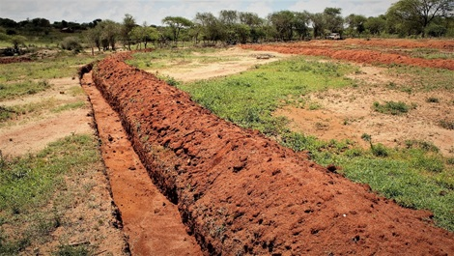

**Figure 5: A recently constructed infiltration trench**

[**http://fmnrhub.com.au/reversing-land-degradation-yatta-kenya-2/**](http://fmnrhub.com.au/reversing-land-degradation-yatta-kenya-2/)**.**

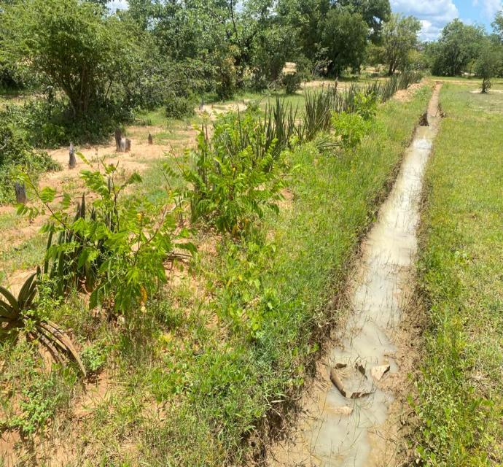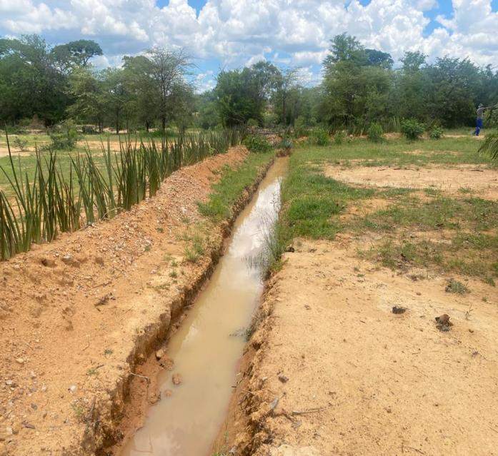

**Figure 6: Established infiltration trenches after a rainfall event (Credit – S. Maseko)**

Monitoring and Maintenance:

Infiltration trenches are generally low maintenance, but need to be checked to ensure they do not silt up or the banks erode.

1. The trench should be inspected regularly to make sure that it is collecting runoff water and the water is infiltrating into the soil.
2. Make sure the trench is not affected by any new construction or activity that could change the way water is flowing or collected for infiltration.
3. 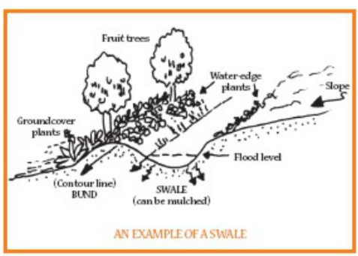Ensure there is enough space between the trench and any adjacent structure or features to allow for maintenance and movement of people or animals.

**Figure 7: Representation of an infiltration trench (swale) (Credit - Mahlathini Development Foundation)**

**II. Half-moon infiltration systems**

Description:

Half-moons, also known as semi-circular bunds are water-harvesting structures used to capture and retain rainfall on rangeland and in agricultural fields. They are designed to capture large volumes of water to infiltrate into the soil to increase the quantity of water to plants, extend the period of available moisture and generally to reduce runoff and soil erosion. Half-moons are typically constructed in semi-circular shapes along the contour lines of sloping land to maximize water retention and to promote plant growth, typically perennial plants.

Dimensions:

Determine the radius and the spacing of the half-moons based on the slope of the land and of sufficient size to retain the runoff water from a storm. A typical radius will be 1.5 to 2 metres making the width of the half-moon 3 to 4 metres, see figure 8 below.

Site selection:

Each half-moon is placed between the two half-moons above it – so they overlap each other to ensure that all runoff water is trapped within a half-moon basin. The distance between the adjacent half-moon and the line of half-moons above will be approximately equal to the radius of each half-moon.

**Figure 8: Positioning of Half-moons**

[**https://www.greener.land/index.php/product/demi-lunes-semi-circular-bunds/**](https://www.greener.land/index.php/product/demi-lunes-semi-circular-bunds/)**.**

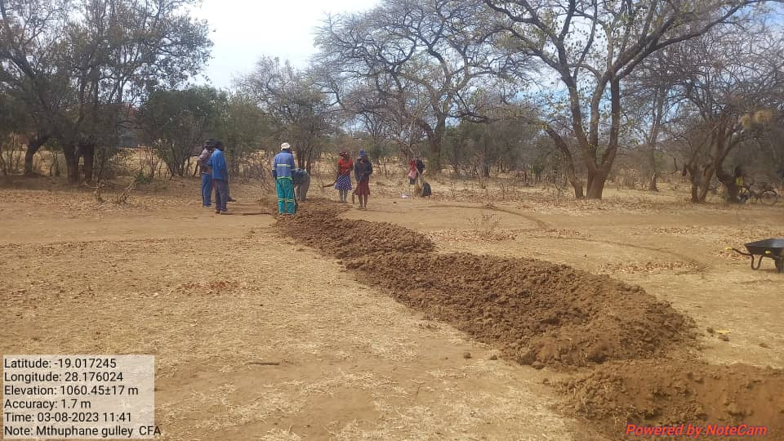

**Figure 9: Construction an initial line of Half-moons (Credit – S. Maseko)**

Design:

* Mark an initial line roughly on the contour.
* Tie two pegs together so they are the radius of the half-moon apart.
* Drive one peg into the soil along the contour line and scribe a half circle with the other peg.
* The distance between each half-moon should be approximately the radius of each half-moon.

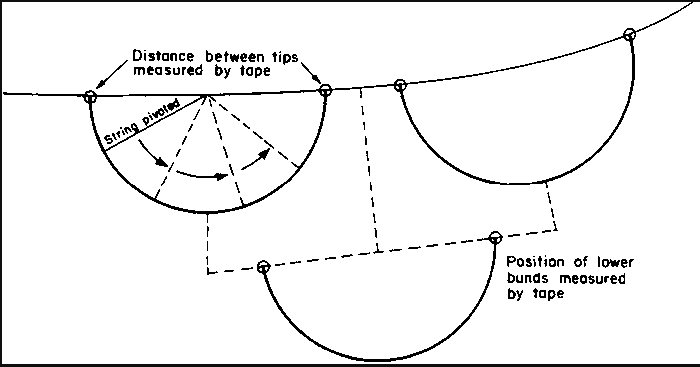

**Figure 10: Shaping and spacing of Half-moons**

[**https://www.fao.org/3/u3160e/u3160e07.htm**](https://www.fao.org/3/u3160e/u3160e07.htm)**.**

Method:

1. Excavate a trench on the marked semi-circular line, ensuring a consistent width and depth throughout.
2. Place the soil dug from the half-moon trench to create a small bank on the lower, the outside of the half-moon. The trench and bank will harvest water within the half-moon and will stop erosion on the slope.
3. Plants can be placed within the half-moon and on the bank to utilise the harvested water and stabilise the bank, promote water infiltration and prevent erosion. Select plants or grasses that establish well in the area.

Points to Note:

1. Half-moons are most effective on slopes that are not too steep where runoff is causing sheet erosion.
2. Consider how much rain falls in the area and how much runoff there will be to decide the size of the half-moons and how far apart they should be so that they overlap and capture all runoff water.
3. Compact the soil in the banks to prevent erosion and to ensure the harvested water is retained to infiltrate into the soil.
4. Regular maintenance is needed to clear debris or sediment from inside the half-moon to ensure runoff water flows into the half-moons.

**Figure 11: Completed Half-moons**

<https://canadianmennonite.org/stories/%E2%80%98half-moon%E2%80%99-agriculture-helps-african-farmers>.

Monitoring and Maintenance Guidelines:

1. Regularly monitor the half-moons for signs of erosion, excessive sediment accumulation or damage.
2. Inspect the half-moons after rainfall to ensure they are retaining water effectively.
3. Maintain the vegetative cover on the banks to stabilise and prevent erosion.
4. Periodically check the half-moons for any sign of structural damage or erosion and repair or reinforce as necessary.

**III. Stone Bunds**

Description:

Stone bunds are structures constructed across a slope to slow the flow of water so that eroded soil particles carried in flowing water are deposited. They are built along contour lines so there is no accumulation of water that could cause erosion, and runoff rainfall is infiltrated into the soil to recharge groundwater. They are effective soil conservation measures used in areas with a slight slope, 5% or less. Water should flow through the spaces between the stones and rocks of the bund which slows the flow to allow infiltration and eroded soil particles to be deposited.

Dimensions:

The height and length of a bund will depend on the specific needs of the site but generally, they should be 0.30 – 0.60 metres high and as long as required to slow the flow of water down a slope. The width of the bunds can vary from 0.5 to 1.00 metre depending on the gradient of the slope. However, there are no hard and fast dimensions of bunds. Construction is more dependent on the availability of material. Any line of rock on the contour will assist in impeding the flow of water so that it infiltrates into the soil before it has sufficient flow to dislodge soil particles and cause erosion. Ideally, large rocks form the base of a bund with smaller rocks placed in front and on top of the large rocks.

Site Selection:

1. Conduct a site assessment to identify the slope of the land, the direction of surface water flow, the soil type and the positioning of lines of bunds and the distance apart.
2. Determine the dimensions and layout of the bunds based on the site's characteristics and the anticipated volume of runoff water to be managed.
3. Clear debris along the contour line where the stone bund will be constructed.
4. Mark out each contour line using an A frame or line level. The line can be adjusted slightly to allow the bunds to form an even regular line. Put smaller stones on the higher side of the trench and use them to fill large gaps between rocks and large stones.

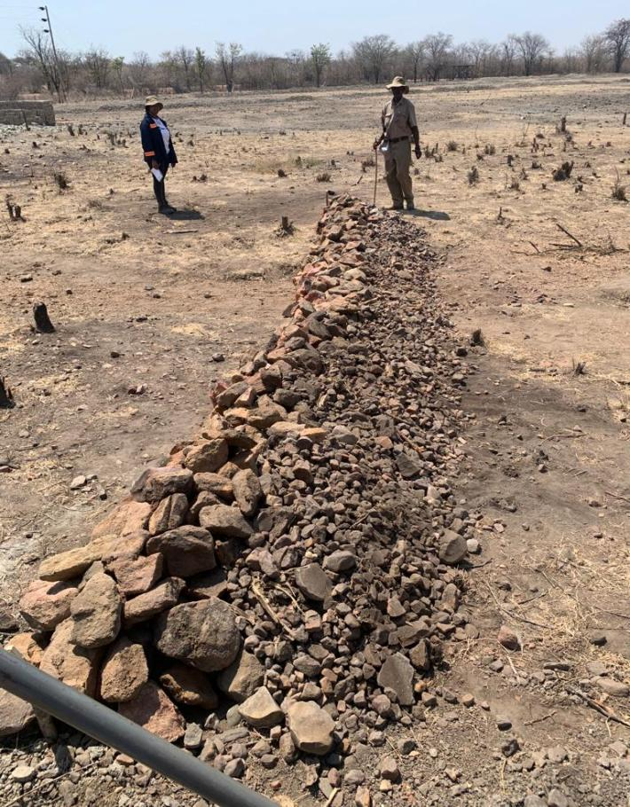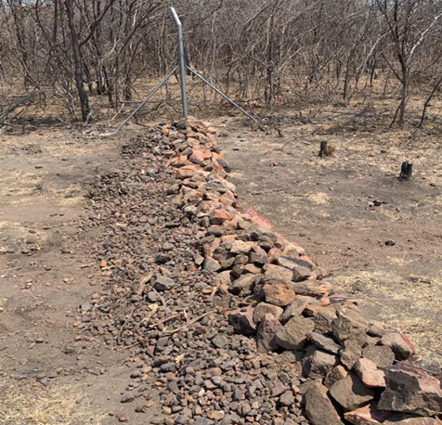

**Figure 12: Completed stone bunds (Credit – T. Muzuva)**

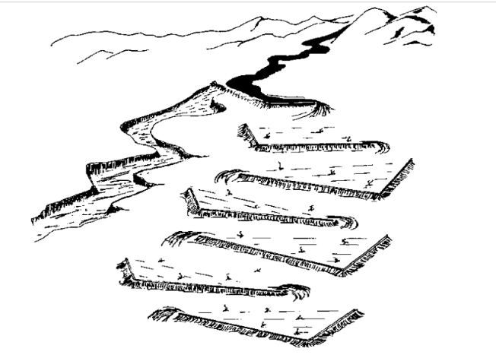

**Figure 13: Runoff diversion system above a gully with bunds for water infiltration.**

[**http://www.greener.land/index.php/product/water-spreading-from-gullies/**](http://www.greener.land/index.php/product/water-spreading-from-gullies/)**.**

Points to Note:

1. Ensure that the bunds are constructed along a contour line to maximize water spreading and to minimize erosion.
2. Consider the local rainfall and volume of runoff to determine the appropriate dimensions and spacing of the bunds.
3. Construct the bund with rocks and large stones on the lower side of the bund that will not be dislodged with water flow and place smaller stones in front and on top.
4. Provide regular maintenance to replace any dislodged stones and to remove debris or excessive sediment build-up that may obstruct or limit water flow through the bund.
5. Water should flow through the bund, not over it. The purpose is to sufficiently reduce the velocity of flow so that soil particles are retained and not transported in the flowing water.
6. Concrete should never be used in bund construction. If the bund is a solid wall, water will inevitably flow over the structure and not through it. This increases the velocity of flow as it cascades over the structure, causing additional erosion on the downstream side. Solid structures often lead to water flowing around the end of the structure which causes erosion and increased degradation due to a wider gully leaving a useless solid structure in the centre of a larger gully, see figure 14 below.

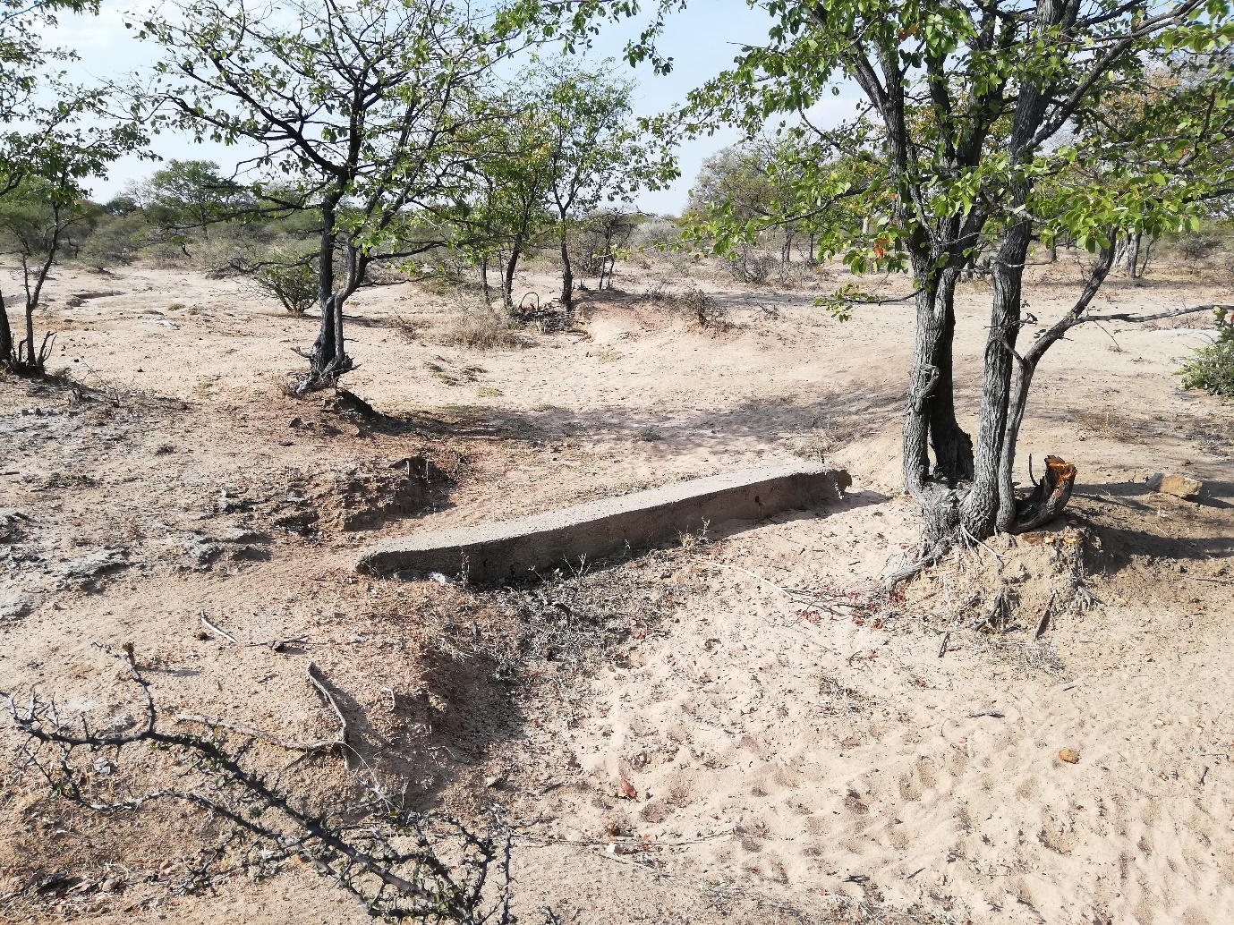

**Figure 14: Example of an incorrectly constructed bund which has increased, not reduced the gully. (Credit – S. Hussey)**

Monitoring and Maintenance:

1. Assess the stability and alignment of the stones.
2. Regularly monitor the bunds for dislodged or missing rocks, signs of erosion, sediment accumulation, or damage.
3. Remove any debris, vegetation, or sediment that may obstruct water flow through the bunds.
4. Inspect the bunds after heavy rainfall events to ensure they are functioning effectively, preventing sheet erosion and increasing rainfall infiltration.
5. Periodically check the bunds for any signs of damage, loss or misplaced stones and repair or reinforce as necessary. Repair any gaps, breaches, or erosion observed in the stone bunds.

**IV. Gabions**

Description:

A gabion is a container for rocks used where the flow of water would overtop or wash away other soil retention and water infiltration systems. Gabions are usually constructed across existing gulleys where there is a high flow of water and thus must be firmly anchored to be kept in place. A gabion comprises a rectangular frame or cage typically formed from 2.4 x 6 metre weldmesh sheets with 4 mm wire and 100 x 100 mm apertures. Suitable dimensions of the frames are a width of 0.6 m and 0.8 m height. The frames are filled with stones and rocks and closed at the top with an additional strip of weldmesh to ensure the rocks remain in place. The frames are placed in a shallow trench across a waterway where erosion is occurring and extend beyond the sides of the waterway to ensure water does not flow around the ends of the gabion, which would then wash away soil, defeating the purpose of the gabion and increasing the width of the gully. Where the gully is deep, two or three gabions may be placed on top of each other in a stepped formation.

The gabion reduces the velocity of the water as it flows between the loose rock in the gabion so that the sediment in transport is deposited upstream of the gabion. In this way gabions are effective erosion control structures that accumulate sediment to fill up gulleys and prevent the siltation of dams and weirs. They are particularly useful in dam catchment and badly degraded areas. They allow water to flow through them, reducing water runoff velocity thereby increasing infiltration which promotes soil moisture retention in the catchment area. Over time, the growth of vegetation within the catchment area enhances the erosion control properties of gabions, ultimately contributing to land reclamation.

Method:

1. Identify an appropriate site for a gabion.
2. Measure the width of the gully.
3. Mark the gabion foundation. (typically 0.7 metres wide x 0.2 metres deep), ensure the foundation extends into the sides of the gully so that when the gabion is installed each end will be higher than the gabion as it crosses the gully to prevent water flow around the ends.
4. Dig a shallow foundation trench:
   * The foundation trench plays a crucial role in providing stability, load distribution and overall structural integrity of the gabion structure.
   * The trench should be at least 0.2m deep and 0.7m wide across the gulley and into the sides to provide stability for the gabion.
5. The foundation trench should be dug to allow 3 or 4 metres of the gabion to be anchored on each side of the gulley banks to prevent water from flowing around the ends of the gabion that would create erosion.

**Note:** The length of the gabion must be greater than the width of the gulley to be closed to prevent water flow around the ends of the gabion.

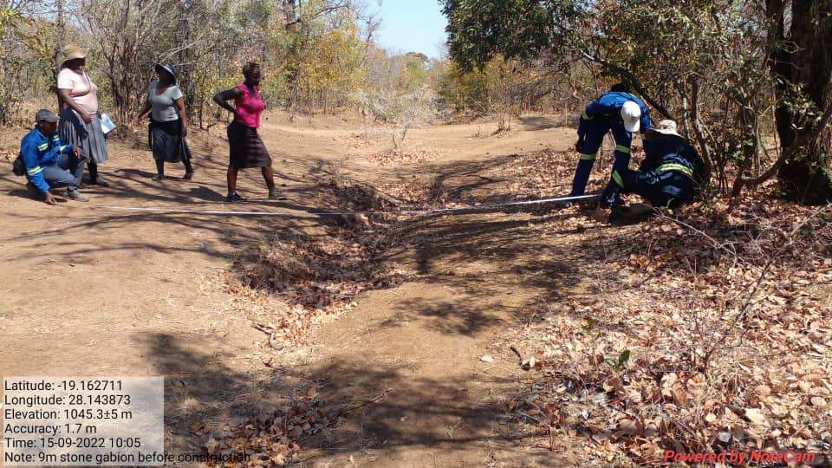

**Figure 15: Preparing a site for a gabion (Credit – S. Maseko)**

**Note:**

* The trench should be wider than the base width of the gabion and deep enough to allow effective anchoring.
* The gabion must extend beyond the width of the gully as shown in figure 16 below.
* The gully can be seen in the mid-ground with people digging a foundation on the side of the gully. When the gabion extends into the side this prevents the situation shown in figure 14 above.

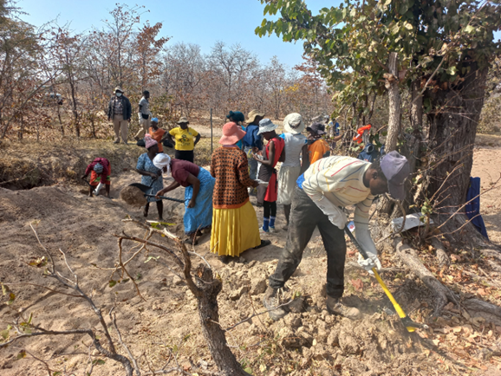

**Figure 16: Digging a foundation for a gabion across and each side of the gully (Credit – S. Maseko)**

**Fabricating a weldmesh frame:**

1. Using one sheet of reinforcement wire mesh 6m x 2.4m x 100 mm x 100 mm apertures, fabricate a ‘frame’ measuring 6m long x 0.6m wide x 0.8m high.
2. Bend the ends of the weldmesh to close the two ends.
3. Place the frame into the foundation trench and fill with stones.

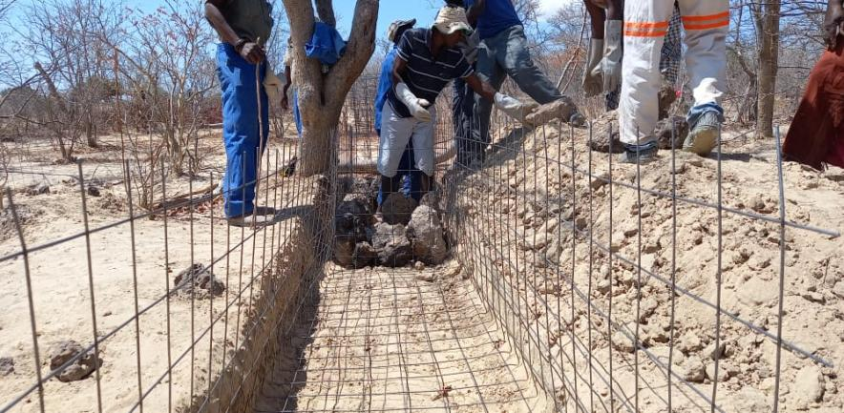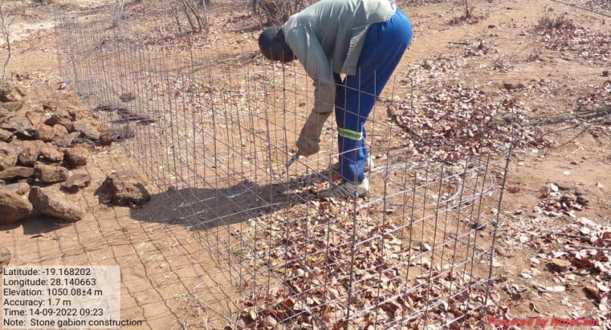**Note:** Start with medium sized stones that are not too big to prevent bulging of the frame.

**Figure 17: Constructing a weld mesh frame for a gabion and rock placement within the frame (Credit – S. Maseko)**

**Closing the Top**

1. Fill the gaps using small stones to produce a level top.
2. After filling the frame with stones, close the top opening using an additional 0.6m x 6.0m strip of weldmesh.
3. 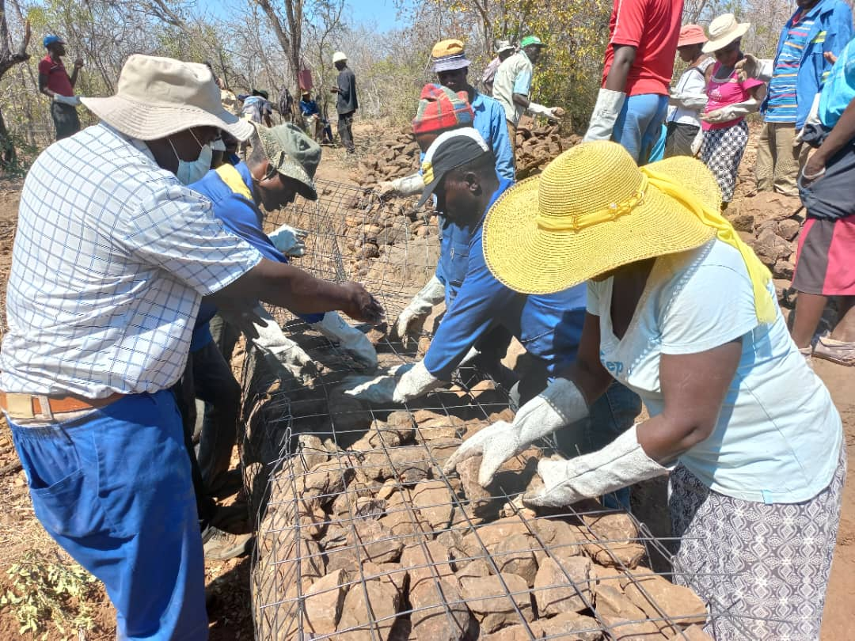Plant Vetiver grass or Sisal along the upstream side of the gabion to prevent the flow of water undercutting the gabion

**Figure 18: Filling gaps with small stones (Credit – S. Maseko)**

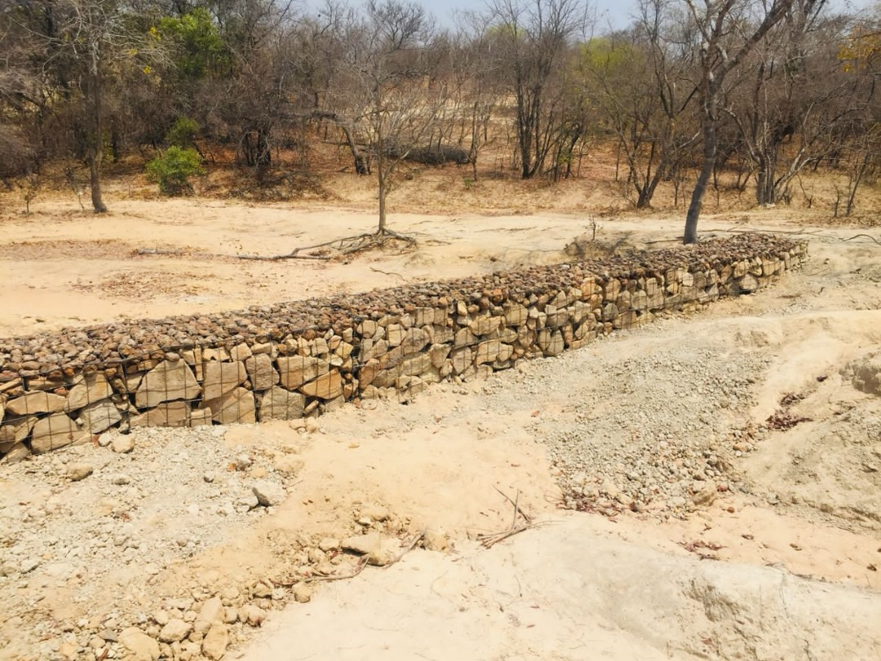

**Figure 19: A completed gabion (Credit – S. Maseko)**

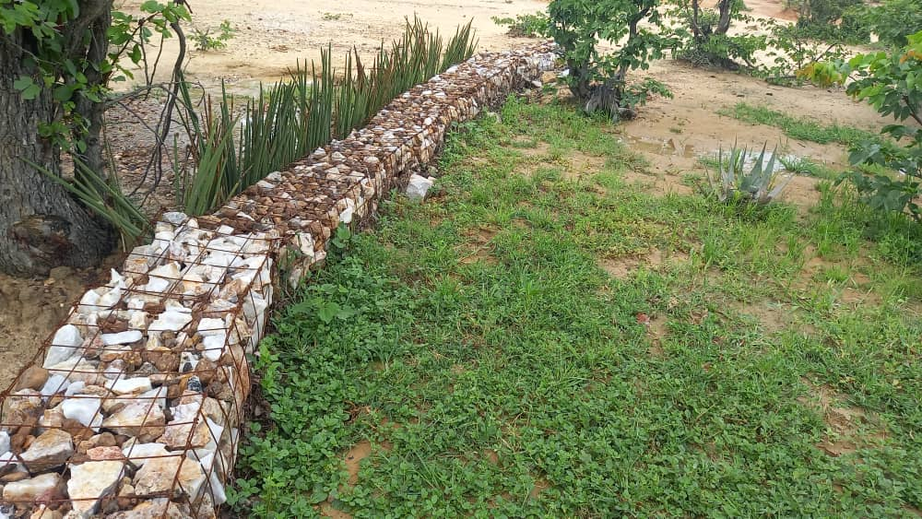

**Figure 20: Shows the soil that has been trapped by the gabion, the natural regrowth of grass assisted by the water retained and the rehabilitation of the gully (Credit – S. Maseko)**

**V. Vegetative Lines**

Description:

Vegetation lines of grasses, shrubs or trees planted across the slope on the contour act as natural barriers to control erosion. Vegetation lines consisting of sisal, aloe, or vetiver grass will slow down runoff water, trap sediment, stabilize soil and prevent the loss of topsoil. Sisal and aloes are easily established and are drought resilient, while vetiver grass effectively controls erosion, stabilizes slopes and improves water management. Vegetation lines are established by placing plants 100 to 150 mm apart on a 150 to 200 metre line. For slopes steeper than 10%, the vegetation lines should be 5 metres apart from each other. This approach effectively controls erosion and promotes sustainable land management practices.

Site selection:

Identify areas where erosion is a problem and where vegetation can be established, typically a site with a gentle slope.

Design:

Determine the length, width, and spacing of the vegetative barriers based on the slope, soil type, and rainfall intensity.

Method:

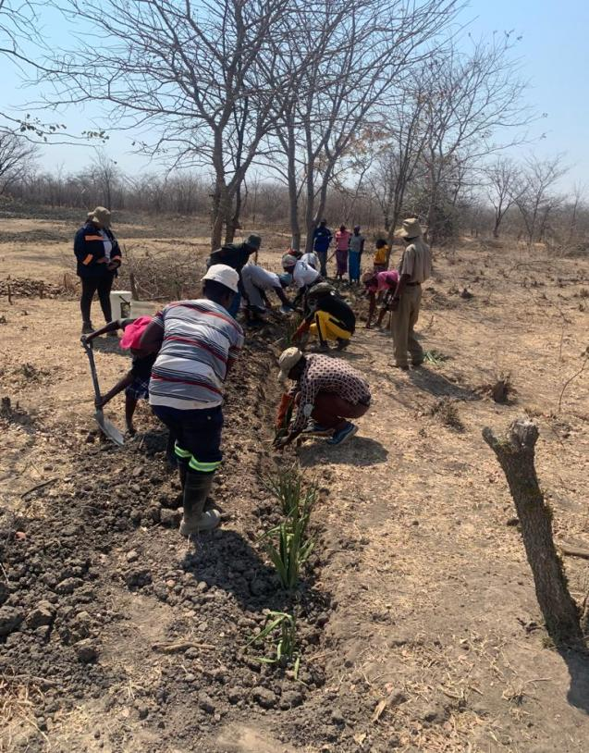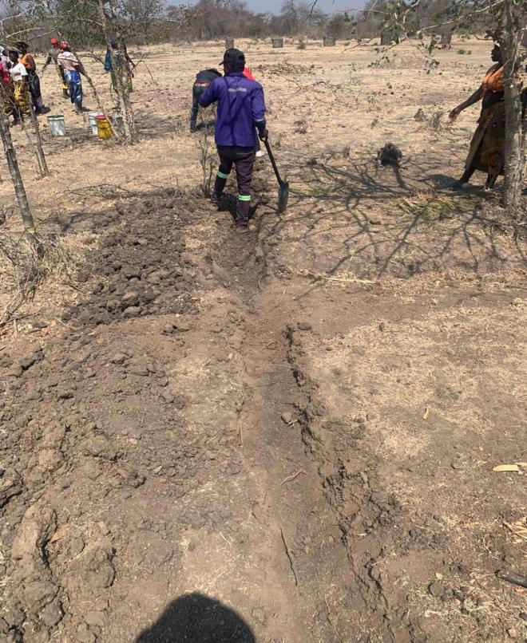Choose a suitable plant species that is adapted to the locality and the site conditions with good erosion control properties. [Sisal is a suitable plant that can be used for this purpose.](https://restory.co.za/2022/03/10/guidelines-for-practical-soil-erosion-control-in-rural-africa/) Plant vegetative lines across a slope at interrow spacings of 0.30 to 0.90 metres. Plant at the beginning of the rains to give the plants the best start to grow. If necessary additional water may be required to establish the plants.

**Figure 21: Preparing the site for a vegetation line (Credit – T. Muzuva)**

Monitoring and Maintenance:

1. In cases where heavy rains or flooding have washed away vegetative measures that were in place to reduce soil erosion, it is important to replant the area as soon as possible and select new plants that are well-suited to the conditions of the area.
2. Regularly monitor the vegetation to make sure that new plants are taking root and the soil is staying in place.
3. 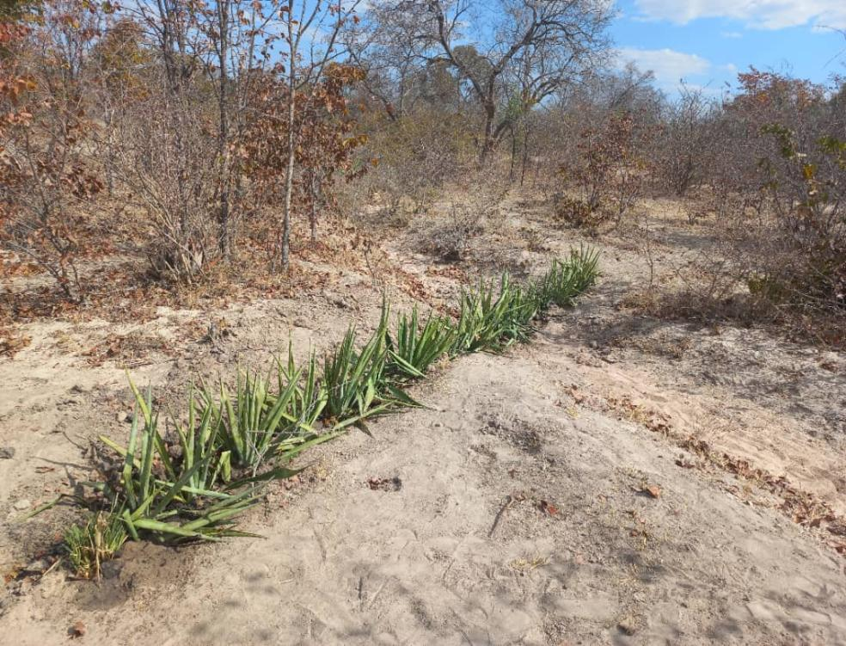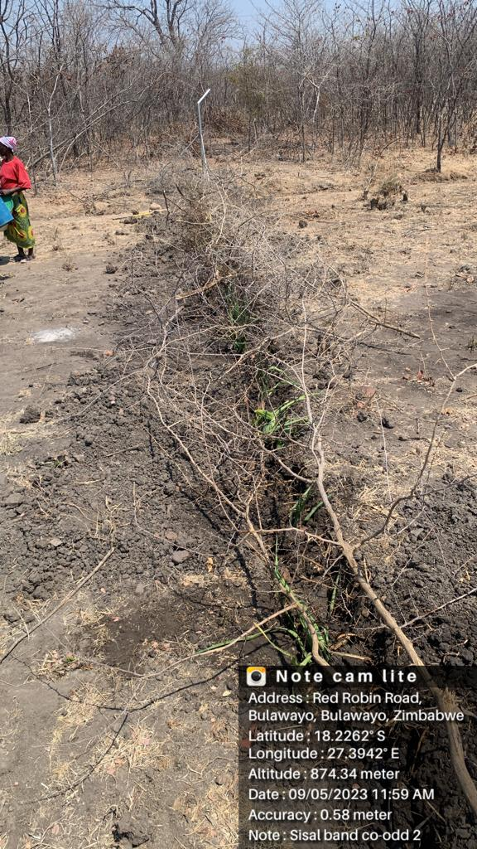As there is no structure to reduce the flow of water check that the vegetation is establishing and that there is no erosion occurring through the vegetation barrier.

**Figure 22: A vegetation line covered with dead brushwood to prevent livestock from damaging the establishing plants and an established vegetation line (Credit – T. Muzuva)**

**VI. Dead-brushwood Barriers and Silt Traps**

Description:

Dead brushwood silt traps, also known as gulley plugs, are barriers made from branches, twigs, and other organic materials placed across gulleys or waterways to trap sediment, reduce runoff, and promote infiltration. Except where there is brushing or pruning of young trees to encourage grass growth, live brushwood should not be used. The technique is only to be used where brushwood is available without cutting any standing bush.

Dimensions:

The width of the barrier at the base should be approximately 1.00 to 1.20 metres and depending on the depth of the waterway, the same approximate height, The length should span the entire width of the gully or drainage line.

Site Selection:

Identify gulleys or waterways where erosion is prevalent or where there is a lack of vegetation cover.

Method:

* 1. Gather dead branches from the surrounding area. Preferably, use material that is denser than the local soil to ensure stability.
  2. Place the collected material in the gully or drainage line to create a barrier across the width of the channel. Use larger branches or logs at the base for stability and add smaller material towards the top. Compact the material slightly to enhance stability. Branches cut as stakes inserted vertically through the barrier into the bottom of the waterway may be required to hold the barrier in place.

Points to Note:

* 1. Dead brushwood silt traps are most effective in gulleys with moderate slopes and low flow velocities.
  2. Ensure that the brushwood is dead and dry and that live vegetation is not being cut that would increase environmental degradation.
  3. Regularly monitor the effectiveness of the silt traps and add material or reinforce them as necessary.
  4. Avoid placing the barrier in areas with high flow velocities, such as on a steep slope.
  5. Regularly inspect and maintain the barrier after heavy rainfall events to prevent clogging and maintain functionality.

.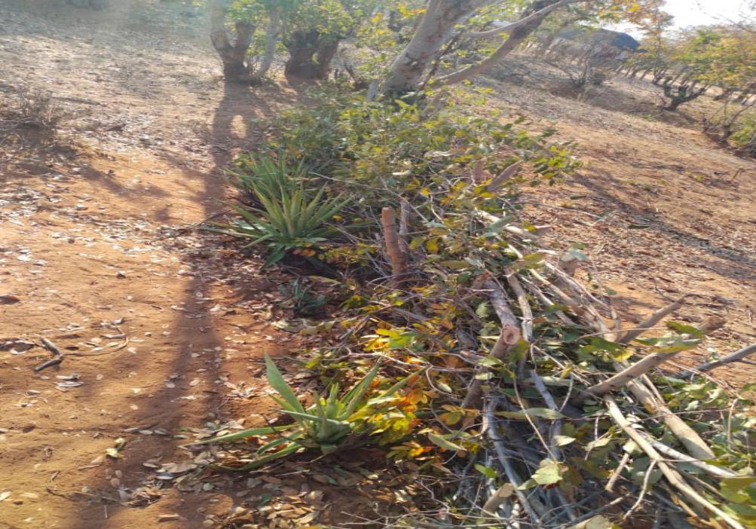

**Figure 23: A dead brushwood silt trap in combination with a sisal vegetation line (Credit – S. Maseko)**

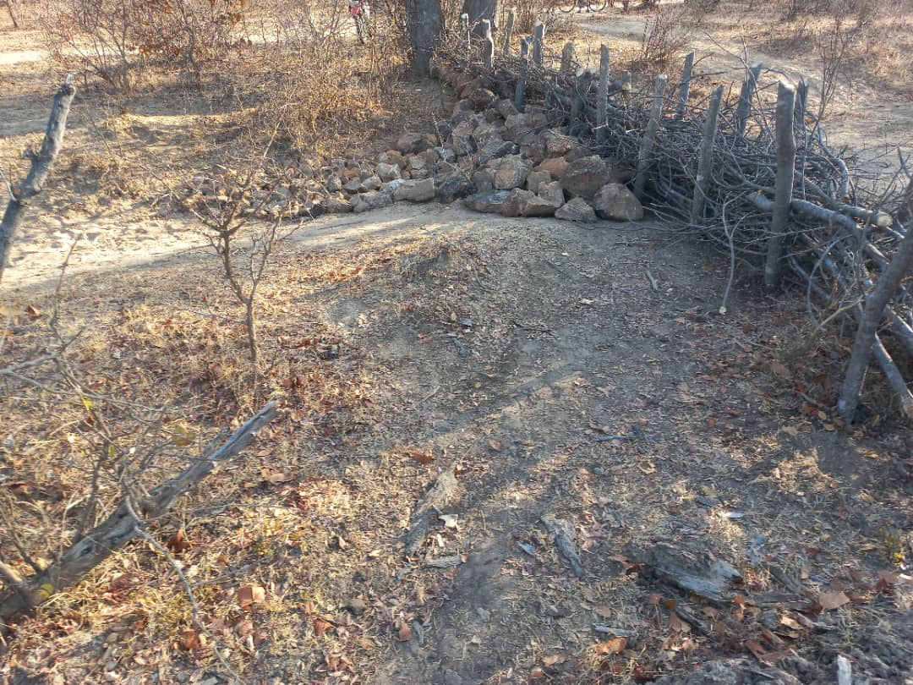

**Figure 24: A dead brushwood barrier with a stone silt trap (Credit – S. Maseko)**

Monitoring and Maintenance:

* 1. Check silt traps regularly to see if they are effective, reducing erosion and trapping sediment.
  2. Maintain the structure’s stability and make sure it stays in a good condition.
  3. Check for signs of erosion or damage and fix or strengthen the silt traps as needed.
  4. Maintain vegetation on and around the silt traps to help control erosion and keep the barriers stable.

**Arable land Infiltration systems**

**Zaï farming:** **Ntwasa/Pfumvudza, basins, ‘potholes’, listers, tied-ridges**

Description:

The preparation of small pits in which to sow crops is a long established practice. In west Africa it is known as zaï farming, in the USA as ‘Listers’ or tied ridges and locally as Ntwasa, Pfumvudza, basin or pothole farming. Each system comprises a small pit constructed to prevent rainfall runoff and retain water in the plant root zone as it fills with rainwater during a rainstorm. The base of each basin is worked to provide a tilth for germinating seeds which improves infiltration into the soil. Depending on the locality, the season and the rainfall it is also possible to plant on the sides of the basin or between the basins. Although the principle construction is a small, shallow pit. Figure 25 below, designed to retain rainfall where it falls, it is preferable to construct the basins on the contour across a slope so that if the basins do overtop there will be no accumulation of runoff that will lead to erosion and land degradation.

There is an added advantage that manure, compost, fertilizer or mulch can be placed in each basin, again within the plant root zone, and not spread widely over the entire field. The Lister and tied-ridge system differs slightly from the basin system as it comprises continuous ridges across a field that are cross-tied at regular intervals between the main ridges to form a micro-catchment system to prevent water movement between the ridges that would cause erosion as it increases and flows off the field.

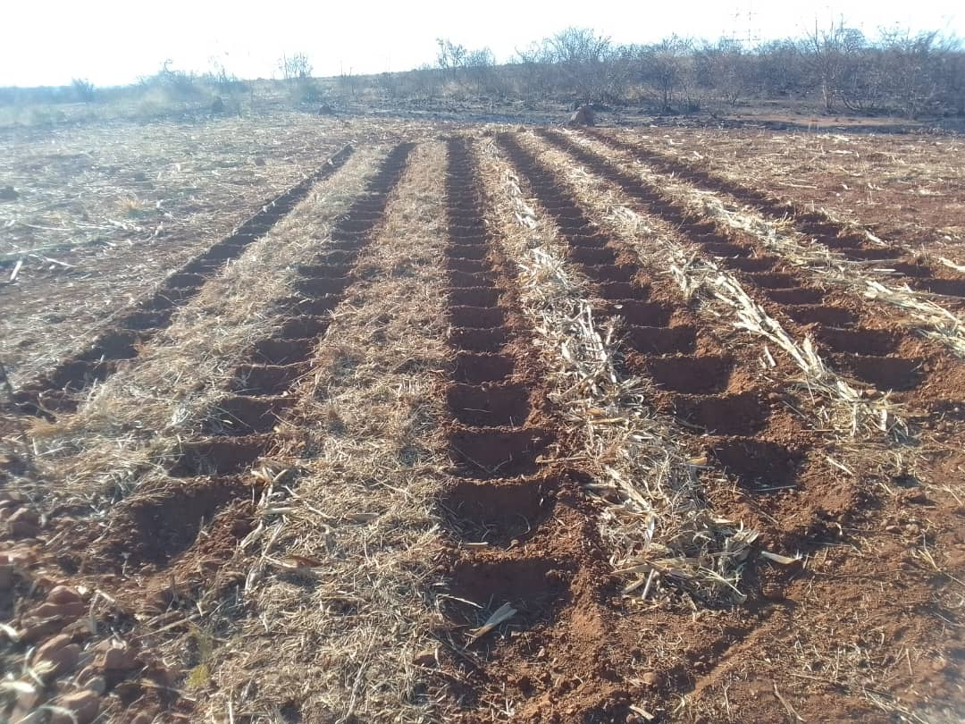

**Figure 25: Land prepared for planting in the Ntwasa/Pfumvudza, basins, pothole system with mulch between the basins. (Credit - D. Nleya)**

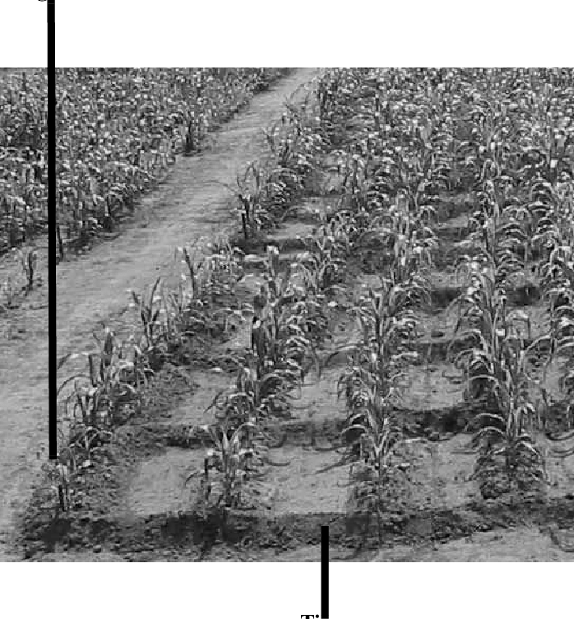

**Figure 26: Tied-ridge with rainwater retained in a micro-catchment**

**‘Water and fertilizer influence on yield of grain sorghum varieties produced in Burkina Faso. South African Journal of Plant and Soil. 26. 91-97. 10.1080/02571862.2009.10639939.**

Dimensions:

There is no determined size or spacing of a basin. A useful guide is a square basin that is easy to construct with a hoe within the range of 300 x 300mm to 400 x 400mm in which one to three plants can grow. If any larger, too much soil will have to be moved to construct the basin, making unnecessary work and if smaller insufficient rainwater will be harvested and retained to benefit the plants. There is also no criteria for the depth of a basin, an overall depth of 150mm to 200mm is typically quite suitable.

Site Selection:

Ntwasa/Pfumvudza, basins, ‘potholes’, listers, tied ridges are best utilised in arable lands which typically have a gentle slope of 5 % or less. Thus, a shallow basin will generally be sufficient to retain the rainfall from a typical storm, especially if the land is regularly ploughed and not significantly compacted, which will improve infiltration.

Method:

As with all rainfall-to-soil infiltration systems it is best to start the opening line on the contour so that the retained water does not overtop one side of a basin or ridge and increase in volume as it flows to a lower level to become the cause of soil erosion and land degradation.

If the basins are constructed by hand a simple and accurate method is to mark out with strings, the distance apart of the plant rows and the inter-row spacing of plants in the cross direction. Where the strings intersect is where a basin should be formed, see Figure 27 below.

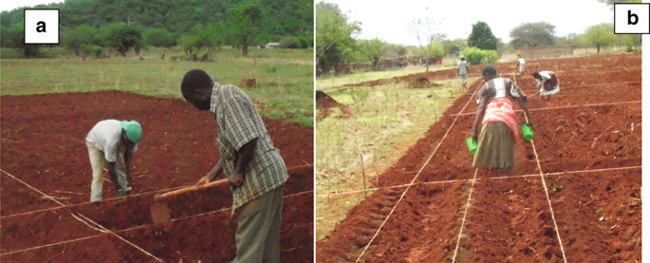

**Figure 27: Method of marking out and constructing Ntwasa/Pfumvudza basins, Listers and tied-ridges**

**Sustainable Intensification to Advance Food Security and Enhance Climate Resilience in Africa (pp.255-271)**

Tied ridges are constructed by forming an open furrow on the contour with a lower ridge across the furrow at approximate 1 metre spacing to form a series of micro-catchments. Figure 26 below. With the Lister and tied-ridge system, planting is typically on the ridge between the micro-catchments.

Points to Note:

1. Whichever system is utilised the initial line that other lines will follow should be on the contour to avoid the catchment systems collecting more water that the soil can absorb.
2. Depending on the slope there may be need to realign the line of basins or micro-catchments to maintain the system on the contour.

Monitoring & Maintenance:

There is little or no maintenance required as the systems are constructed before or early each rainy season to harvest rainwater and retain it within the plant root zone. During the physiological growing period, it will be necessary to hoe the crop to remove weeds, in the process it is likely that basin systems will be destroyed – requiring reconstruction again the following season. Depending on the size of the micro-catchment the tied ridge system may remain intact.

Where basins, listers and tied ridges are constructed in arable lands in a communal land system, livestock are free to roam throughout arable lands and as they range will demolish whatever remains of a conservation system after harvest. Thus the conservation system is constructed new each year.

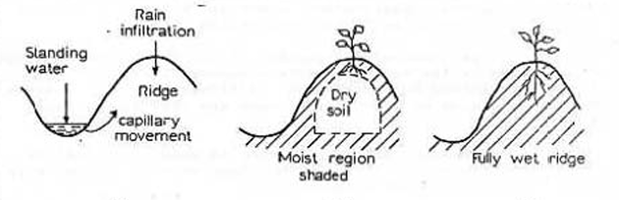

**Figure 28: A fully wet ridge**

**No-Till-Tied-Ridging-Elwell-Norton-1988 PDF (roadsforwater.org)**